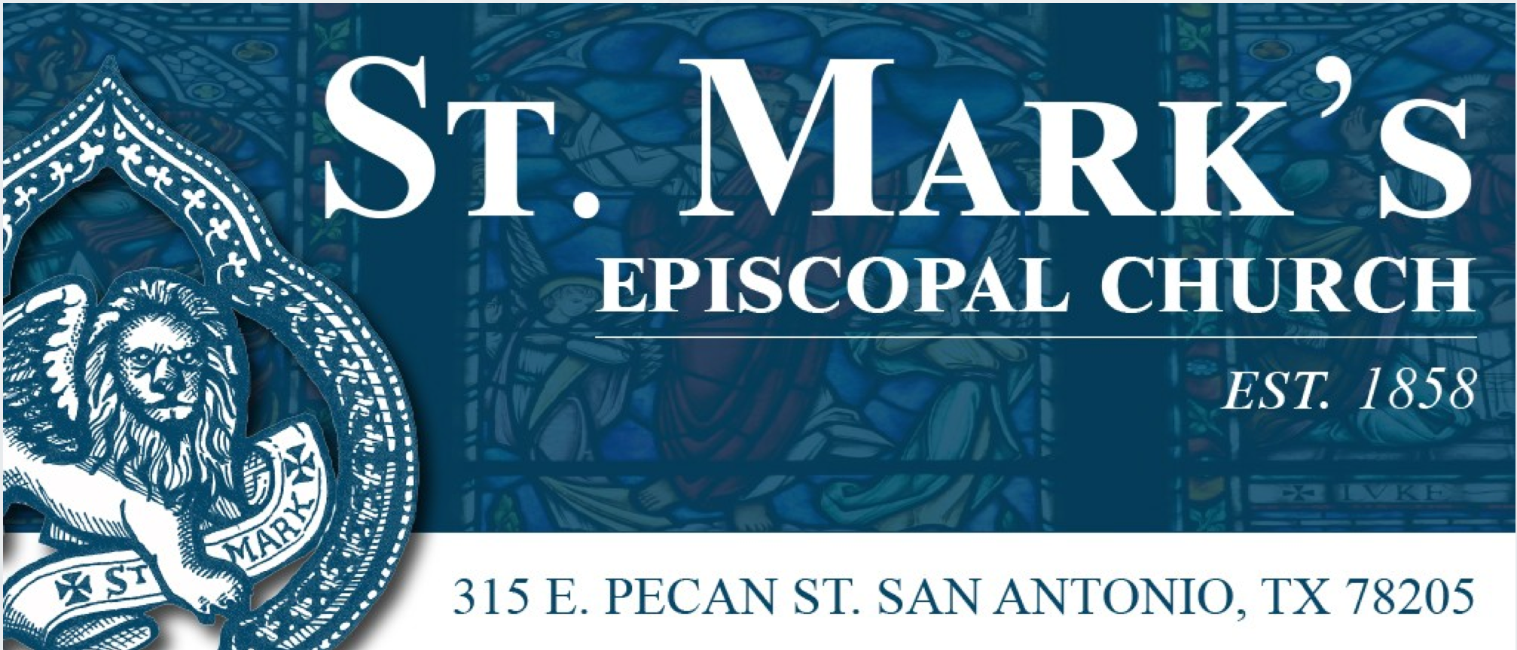
Contact FOR IMMEDIATE RELEASE
Gina Galaviz Eisenberg April 3, 2017
210.254.5661
gina@eisenbergpr.com

Alamo Baroque Festival Scheduled for 2018
St. Mark’s Episcopal Church will host a week of concerts and workshops

San Antonio, Texas—St. Mark’s Episcopal Church is proud to announce it will hold the Alamo Baroque Festival, as one of San Antonio’s official Tricentennial celebrations, January 8-13, 2018. The Alamo Baroque Festival presents historically informed performances of music from the 17th and 18th centuries by internationally recognized artists.
​
“Music written hundreds of years ago can sound as fresh and alive today as when it was first heard,” said Dr. Joseph Causby, Organist/Choirmaster at St. Mark’s Episcopal Church. “Recorders, baroque violins and trumpets, harpsichords, and viola da gamba excite the senses now as they did centuries ago.”

The Alamo Baroque Festival will increase public awareness of the richness and variety of classical music before 1750, create opportunities for the performance of this repertoire, and educate musicians of all backgrounds, ages, and abilities in the techniques appropriate to early music.

“We have the best of the best performing,” adds Causby. “The public performances, master classes, and private instruction are free and open to all.”

What: Alamo Baroque Festival presented by St. Mark’s Episcopal Church

• Free public performances, master classes, and private instruction (by audition)
• The Alamo Baroque Festival covers the large historical span of early music in all of its forms, presenting ensembles that are part of a movement that has swept the world of classical music: historically informed performances of vocal instrument and chamber music, from the Middle Ages through the eighteenth century, using period instruments.
• AlamoBaroqueFestival.org
When: January 8-13, 2018

Schedule:
- Monday, January 8: Instruction with members of The Children’s Chorus of San Antonio
- Tuesday, January 9: Instruction with students from Trinity University and The University of Texas at San Antonio UTSA
- Wednesday, January 10: Public master classes, instruction with member of The Youth Orchestras of San Antonio
- Thursday, January 11: Private instruction and Evening Concert
- Friday, January 12: Private instruction
- Saturday, January 13: Morning concert

Where: St. Mark’s Episcopal Church located at 315 E. Pecan Street 78205

Who: St. Mark’s Episcopal Church, The Royal Academy of Music (London), Children’s Chorus of San Antonio, Youth Orchestras of San Antonio, Trinity University, and The University of Texas at San Antonio

Contact: Joseph Causby, St. Mark's Episcopal Church, 210-226-2425,
jcausby@stmarks-sa.org

Artists: Alamo Baroque Festival Faculty:
Margaret Faultless, Baroque Violin

www.mus.cam.ac.uk/directory/maggie-faultless
Elisabeth Reed, Gamba and Baroque Cello
http://music.berkeley.edu/people/elisabeth-reed-2/
Jacqueline Horner, Soprano
http://www.jacquelinehorner.com
Robin Tyson, Countertenor
http://www.epamartists.com

Paul Phoenix, Tenor
www.purplevocals.com

Alex Ashworth, Bass
http://www.alexashworth.com

St. Mark’s Episcopal Church promotes sacred music, bringing guest musicians into the community and underwriting special musical events. Now in our 25th year of bringing music to the wider San Antonio community, St. Mark's brings together the choirs of St. Mark’s with partner organizations to offer free concerts for the benefit of all. www.stmarks-sa.org
St. Mark's Core Vocation:
Feeding San Antonio with the Bread of Life
- Feeding the hungry with real food
- Feeding those who are hungry for knowledge and meaning
- Feeding those who are hungry for beauty and creativity

###

